**ALGORITHMS - DYNAMIC PROGRAMMING**

This paradigm is bit different but very similar to Divide and Conquer approach.

In “Dynamic Programming” the word “Programming” doesn’t mean we are going to use some programming language, instead, it means that we are going to use some tables and “dynamic” means we dynamically decide whether to use a function or to call a program (use table).

*Whenever our main problem requires solving sub-problems again and again, instead to solving the sub-problem every time we can maintain the solutions in a table and we could use them again.*

Let’s demonstrate with an example.

**Fibonacci Sum:**

**Calculate the sum of the Fibonacci series up to ‘n’ terms.**

Method: This will be calculated as below

$$f\left(n\right)=f\left(n-1\right)+f\left(n-2\right), n>1$$

$$f\left(n\right)=1,n=1$$

$$f\left(n\right)=0,n=0$$

The program for it will look like below along with the recursion tree for this recursive program.



F(n)

{

If(n==0)  
 return 0;  
 if(n==1)  
 return 1;  
   
 return( f(n-1) + f(n-2))

}

Such kind of computation may reach to a time complexity of O(2n) which is exponential. We can see that more than half of the calls to the function F(n) are redundant from the tree. What we can do instead is that *we can save the result of the calls for which we know will be used later in a table in order to reduce the time complexity. The saved result can be checked on every function call for reducing redundancy of calls.*

The modified program can look like.

F(n)

{

If(n==0)  
 return 0;  
 if(n==1)  
 return 1;

*Check the table for T(n)*

*If(T(n) is empty)  
 return( f(n-1) + f(n-2))*

}

Using this approach, the number of calls will be ~ n

**Time complexity = O(n)** *(from O(2n))*



***Note: So, if a problem is having some recursive equation and if the recursive equation shows that the problem is having overlapping sub problems, we can apply dynamic programming to optimize the time complexity of the problem.***



***It will be used when the sub-problems are overlapping. Therefore, there will be recursive problems where DP can’t be used like Merge Sort, etc.***

**Let’s take the problems which apply dynamic programming.**

**MATRIX CHAIN MULTIPLICATION (Dynamic Programming)**

Matrix 1 = 3x2, Matrix 2 = 2x3, resulting dimensions = 3x3

So, how many multiplications (scalar) are required to multiply these two matrices?

Result contains: 3 rows, 3 columns and for each element of this matrix the number of scalar multiplications required = 2.

Therefore, 3x3x2 scalar multiplications are required to multiply these two matrices.

From this result:

1. **Matrix A dimensions = PxQ**
2. **Matrix B dimensions = QxR**
3. **Number of scalar multiplications required to multiply these two matrices = (PxR)xQ**

Let’s extend it to three matrices.

1. Matrix multiplication is associative in nature this means ((AxB)xC) = (Ax(BxC))

Let’s take two examples with different *parenthesized* as associativity can allow and calculate the number of scalar multiplications required to multiply the three matrices.



So, by changing the way we select the multiplication order we can bring down the number of scalar multiplications required to multiply matrices.

If the dimensions of the matrices were significantly large we would have seen very significant effect of the optimal selection of the parenthesized structure which is going to give me least number of scalar multiplications.

For three matrices there are two ways to parenthesize. Let’s see for ‘n’ matrices how many ways there will be to parenthesize.

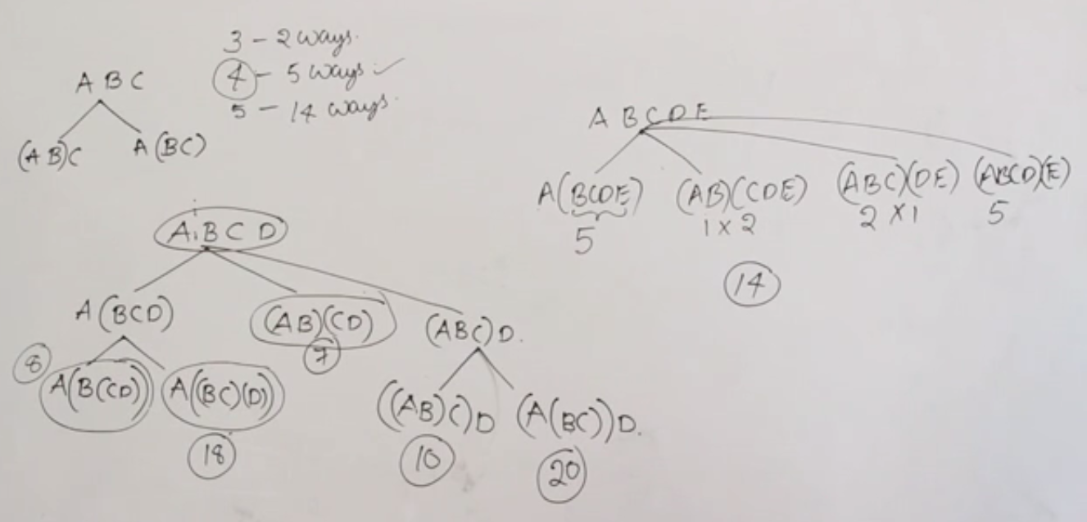

There is also a formula for calculating the number of ways a matrix chain multiplication can be parenthesized. It is given as:



$$\frac{\left(2n\right)!}{\left(n+1\right)!n!} where n=(number of matrices in the chain-1)$$

For 6 matrices, number of ways it can be parenthesized = $\frac{10!}{6!5!}$ =



**To solve this problem using dynamic programming, I need to have**

1. **Optimal Substructure: Given the big problem, I should be able to write it in terms of small problems in such a way that the solutions to the small problems put together should make the solution to the big problem.**
2. **Overlapping Problems: When I am solving some problem there should be a smaller problem that is a part of the other small problem as well. Thus the smaller problems should be overlapping**

**OPTIMAL SUBSTRUCTURE and RECURSIVE SOLUTION for MATRIX CHAIN MULTIPLICATION**

**Optimal Substructure**

To solve the problem using dynamic programming, first we divide the problem into smaller ones and then after that we can find a recursive solution for it.

**Some conventions:**



**Chain Multiplication:** A1 A2 A3 … An



**Dimensions:** p0xp1 p1xp2 p2xp3 …. pn-1xpn



Generally, if I have the Matrix chain multiplication as, I can parenthesize as:



$$A_{i}A_{i+1}A_{i+2}…A_{j}= A_{i}A_{i+1}…\left.A_{k}\right|A_{k+1}…A_{j}$$

Dimensions:



**Total number of scalar multiplications:**

**Numscalar mul( + Numscalar mul( + pi-1xpkxpj**

**Recursive Solution/Equation**

Let’s introduce another term m[i, j]

*m[i,j] = minimum number of scalar multiplications required in order to parenthesize A[i] to A[j]*

So the base condition for recursive equation will be: *whenever I have only one matrix to multiply, the minimum number of scaler multiplications= 0*

When i≠j, then we have to parenthesize and calculate the minimum number of scalar multiplications. The recursive equation can look like:

$$m\left[ⅈ,j\right]=\left\{\begin{aligned}0,ⅈ=j \\ \min\left\{m\left[ⅈ,k\right]+m\left[k+1,j\right]+pi-1 . pk. pj\right\}, i≤k≤j\end{aligned}\right.$$

Now we know how to split, but we don’t know where to split, so we have to consider all the possibilities. The number of possibilities we get:

K can be $ⅈ,i+1,i+2,…,j-1$ therefore, **( j – i ) possibilities**

When we are going to split there will be (j – i) ways.

*The next part you should be looking at is whether there are overlapping sub-problems or not.*

**Overlapping sub-problems**

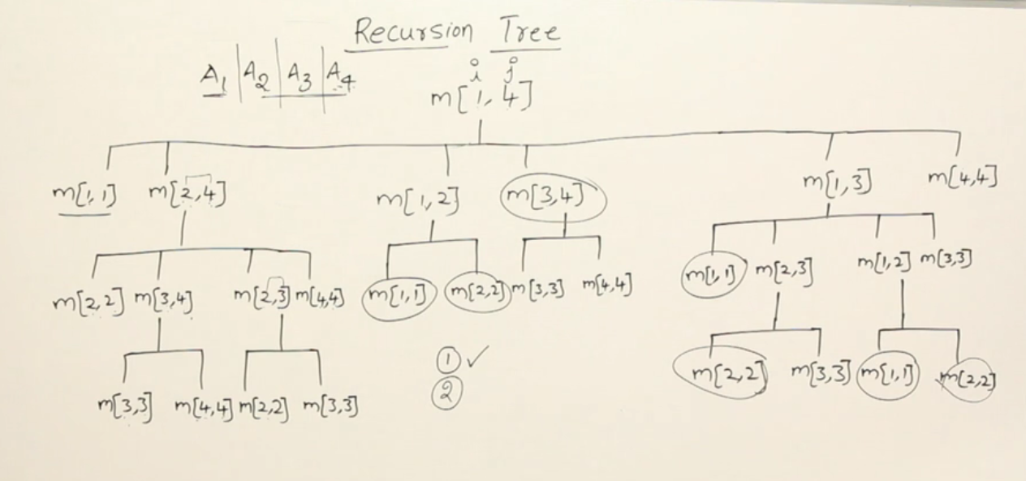

Above is the recursion tree for the ways in which 4 matrices can be multiplied. The notation m[i,j] denotes the scalar multiplications required to multiply m[i,j] chain of matrices.

We see that a lot of calls to the functions are repeated, like m[1,1], m[2,2], m[3,4] etc.

Therefore, ***there are overlapping sub-problems.***

So, we can reuse the calculations for such repeated calls by storing the values in a table.

**This storage of values in a table can be done in two ways:**

1. **Bottom-up approach:** go to the bottom from top, calculate the bottom level’s values then move one level up until you reach root
2. **Top-down approach:** follow the tree the way recursion happens and as you call the function, calculate the value and store it in the table.

So, how are we going to store them in the table?

**DYNAMIC PROGRAMMING BOTTOM UP INITIATION FOR MATRIX CHAIN MULTIPLICATION**

**For A(1,4)**

From the recursion graph above, the unique function calls are made as follows:

(11) (22) (33) (44) Size of problem = 1 No. of sub-problems of size 1 = 4

(12) (23) (34) Size of problem = 2 No. of sub-problems of size 2 = 3

(13) (24) Size of problem = 3 No. of sub-problems of size 3 = 2

(14) Size of problem = 4 No. of sub-problems of size 4 = 1

Total number of sub-problems = 4+3+2+1 = 10

**For A(1,n)**

Total number of sub-problems = n + (n-1) + (n-2) + …+ 1 = $\frac{n\left(n+1\right)}{2}$

Therefore, in order to solve a matrix chain multiplication of A(1…n) the number of sub-problems you may have to solve is $\frac{n\left(n+1\right)}{2}$.

Let’s take an example:

**Example: Find the least number of scalar multiplications required in multiplying the following 4 matrices with dimensions given.**

|  |  |  |  |
| --- | --- | --- | --- |
| A1 | A2 | A3 | A4 |
| 1x2 | 2x1 | 1x4 | 4x1 |



The unique sub-problems are as follows. Let’s find the total scalar multiplications required for each sub-problem.



**(11) (22) (33) (44)**



**(12) (23) (34)**



**(13) (24)**



**(14)**



1. (11) (22) (33) (44)
   1. The number of scalar multiplications here will be 0.
2. (1,2) = 1x2x1 = 2
3. (2,3) = 2x1x4 = 8
4. (3,4) = 1x4x1 = 4
5. (1,3) =



1. (2,4) =



1. (1,4) =



Now, the time taken to find out the minimum number of scalar multiplications will depend on number of splits and total number of sub-problems.

1. For A(1,4) number I had to look at 4-1 = 3 splits and each split takes O(1) time so for A(1,n) I will have to look at (n-1) splits for each split O(1) time so for looking at the splits I need **O(n)** time.
2. In order to solve a matrix chain multiplication of A(1…n) the number of sub-problems you may have to solve is $\frac{n\left(n+1\right)}{2}$

**Total time complexity for matrix chain multiplication with dynamic programming bottom-up method = O( = O(n3) (WORST CASE)**

**Space Complexity = O(n2)** (to store the $\frac{n\left(n+1\right)}{2}$ sub problems)

**MATRIX CHAIN MULTIPLICATION USING DYNAMIC PROGRAMMING TOP DOWN APPROACH (MEMOIZATION)**

Using the top down approach, also called memoization, has the same time complexity as that of the bottom-up approach. Since this algorithm is a recursive one the space complexity is a little more than that of the bottom-up approach as the stack for recursive calls is also maintained (stack size = the height of the recursion tree). But, the worst case time and space complexity is same.

Time complexity = O(n3)

Space complexity = O(n2) + O(height of recursion tree) = O(n2) (worst case)

Example: Gate 2011



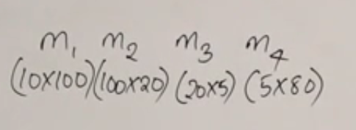



Find the least number of scalar multiplications required for multiplying the matrices.



**(11) (22) (33) (44)**



**(12) (23) (34)**



**(13) (24)**



**(14)**

